**LAB PROGRAM 1:**

Write a C program to simulate the following non-pre-emptive CPU scheduling algorithm to find turnaround time and waiting time for the following:

1. First Come First Serve (FCFS)
2. Shortest Job First (SJF)
3. Shortest Remaining Time First (SRTF)

**OBSERVATION:**

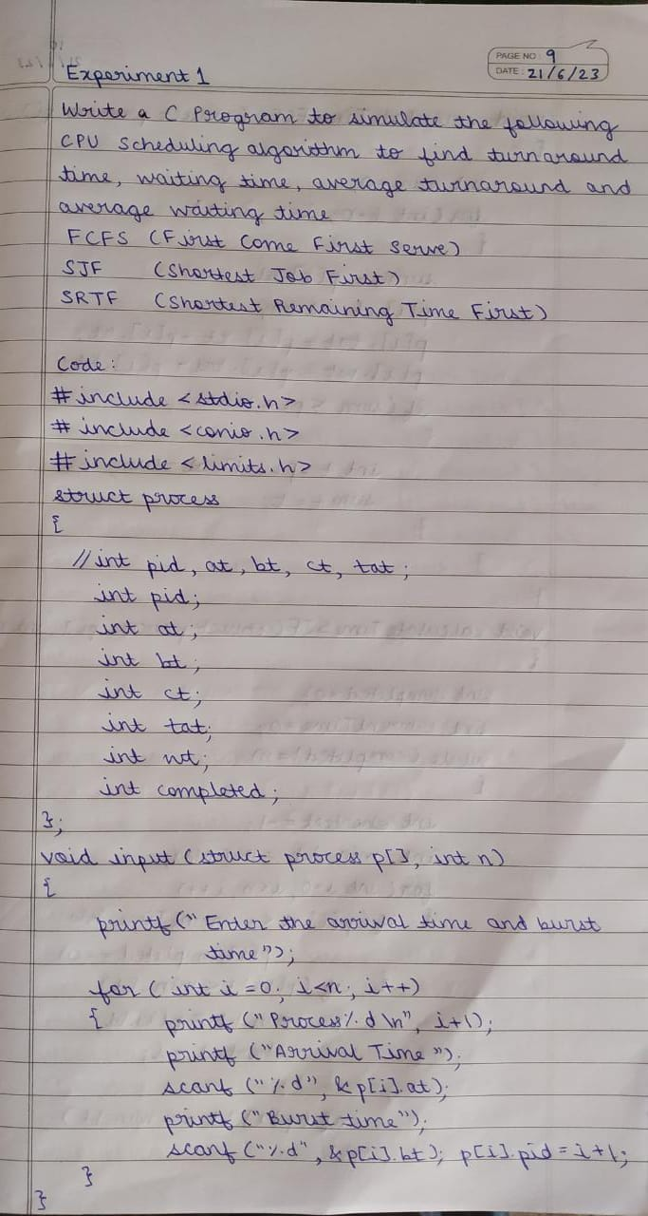

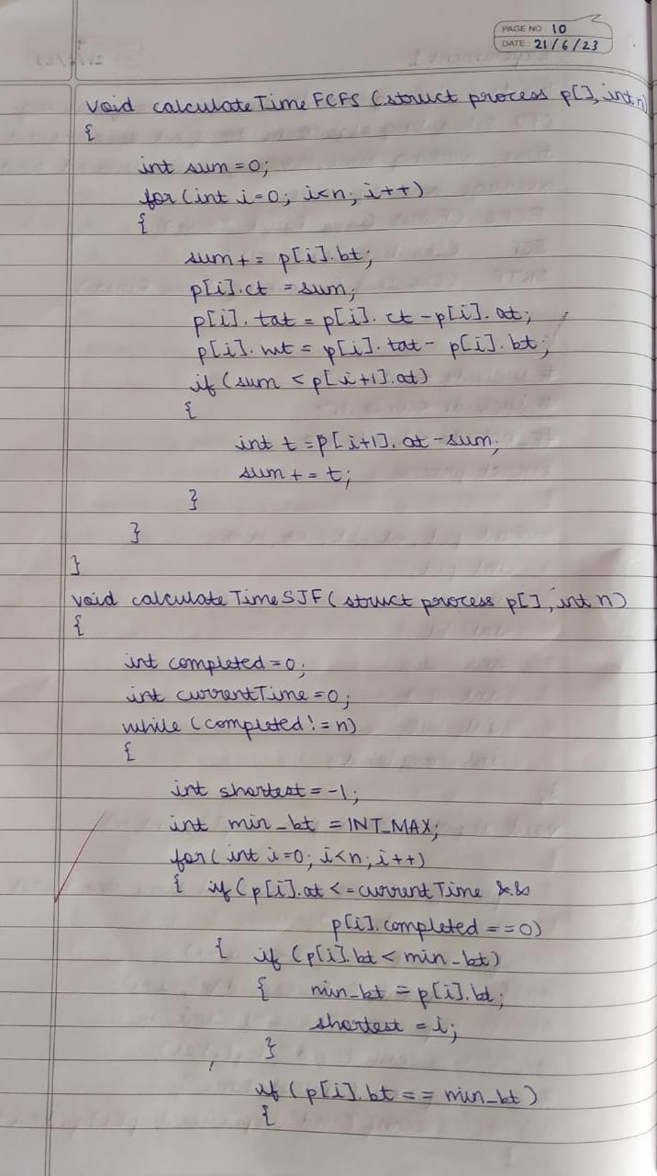

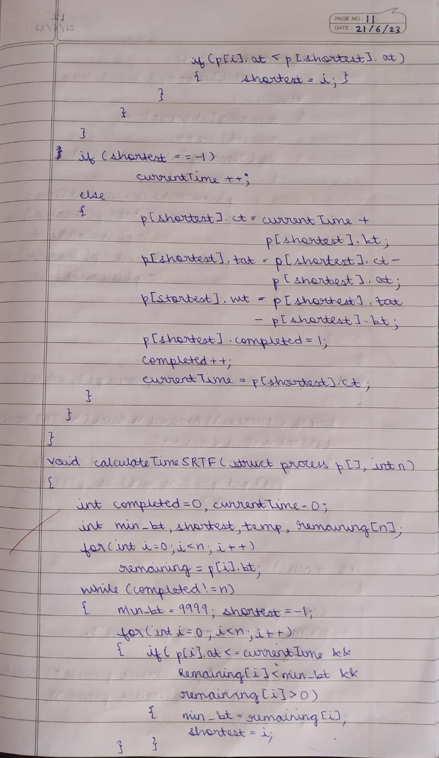

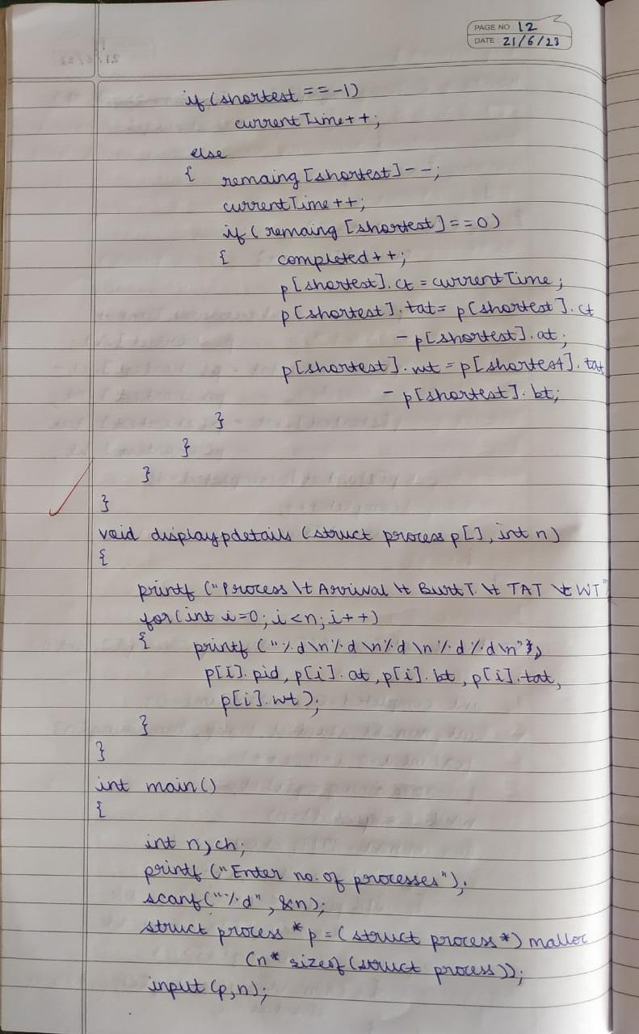

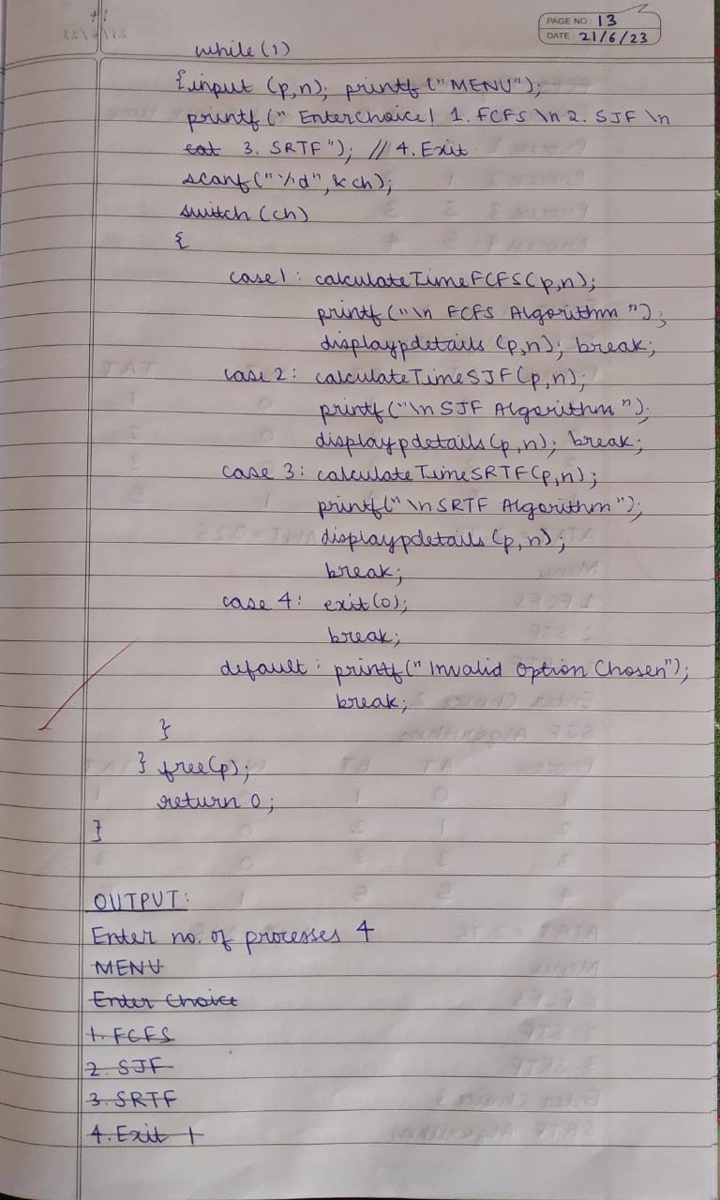

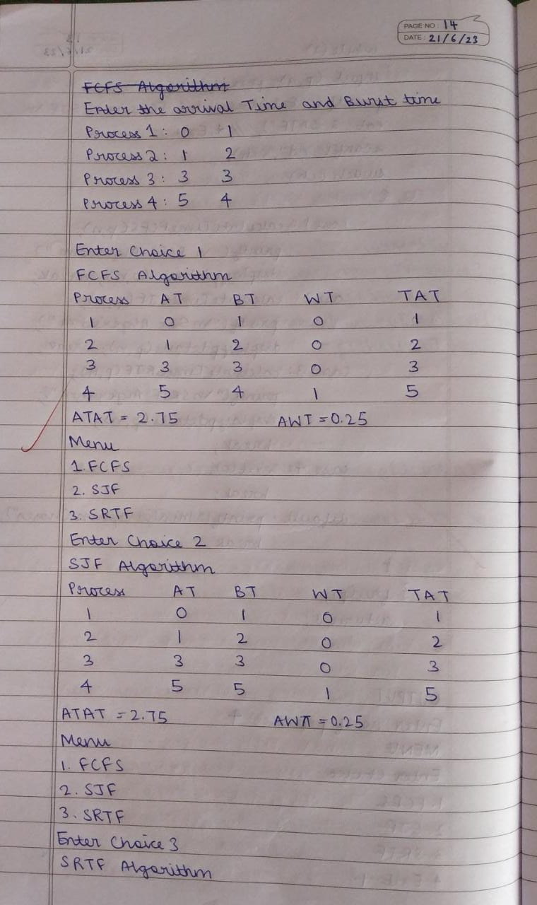

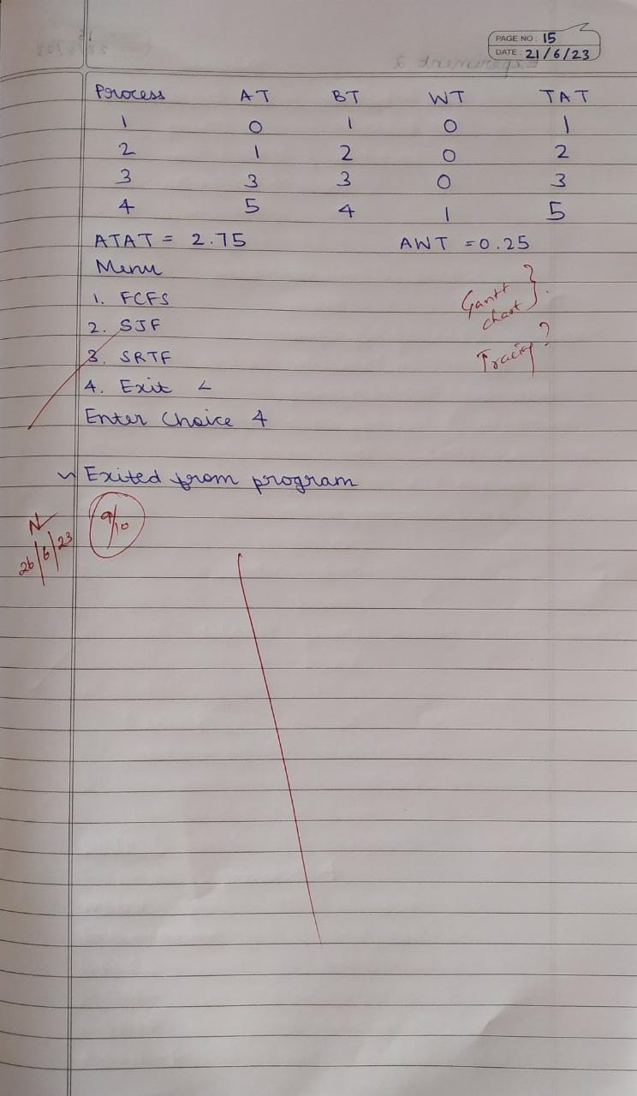

**OUTPUT:**

